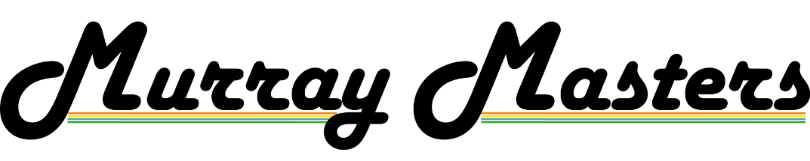

Murray Masters Fee & Cancellation Policy 2023
To secure registration a one-day Murray Masters 2023 Golf Fee of $30 is required as a non-refundable deposit*.
Balance be paid in full no less than one (1) month prior to the event.
Refunds for cancellations are as per the below:

 | Refund policy
> 14 days from event | Fees paid less $30 non-refundable deposit refunded to entrant
7 – 3 days from event | 50% of total event package refunded to entrant.  Please note: Accommodation fees if relevant for entrant will be included in calculations.
Within 48 hours from the event | 25% of total event package refunded to entrant.  Please note: Accommodation fees if relevant for entrant will be included in calculations.
Adverse weather | No refunds or credits issued for adverse weather unless course is closed due to weather conditions.  In the event of course closure, a refund will be issued for the golf fee for day of course closure only.

If applicable refunds will be issued within 10 business days via electronic bank deposit or original payment method, to original entrant via the Howlong Golf Resort accounts team.

*The $30 deposit will be applied to your Murray Masters balance, however in the unfortunate event that you do have to withdraw from the event this deposit will be retained in full to cover administration costs.

